Table of Contents

Sites Configuration 2

Location Configuration 6

Location Type Configuration: 6

Storage Location Configuration: 8

Equipment Types Configuration 9

Workflow Configuration 10

Add Material Type 10

Add Material 11

Add Workflow Items 12

Add Workflow 13

Master Workflow Configuration 20

Test Configuration 21

Comments Management Configuration 24

Manual Steps to Accession Sample and process the workflow 28

Add New Trial 28

Create Accession 32

Process Workflow 32

# Sites Configuration

* Open “Sites” application. “Resources>Sites”

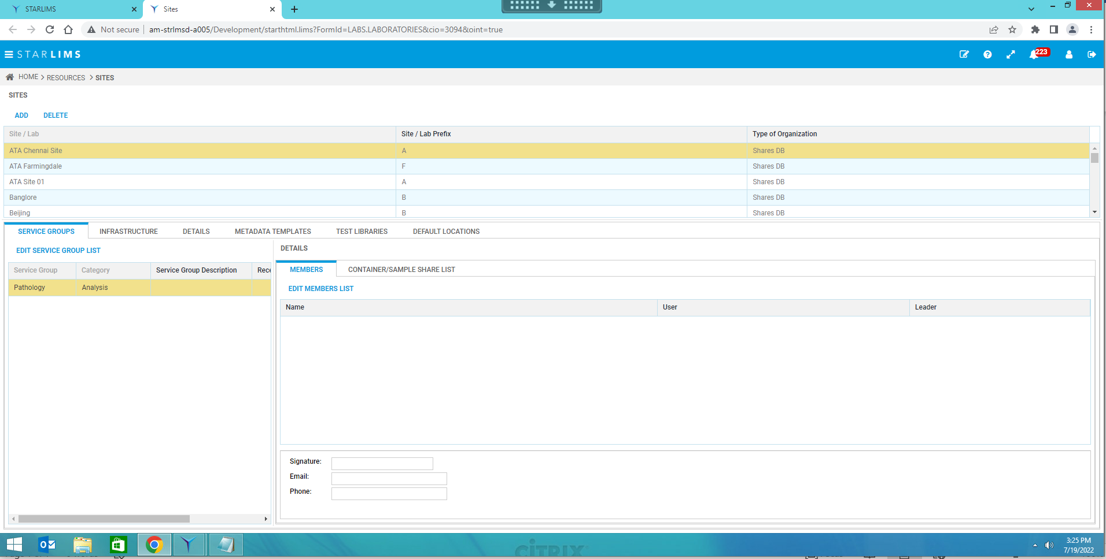

* Click on Add button to add Sites.
* Enter Site name, Site Prefix- and Type of Organization.

* Now in Service Groups Tab add service groups by clicking on Edit Service Group List button.

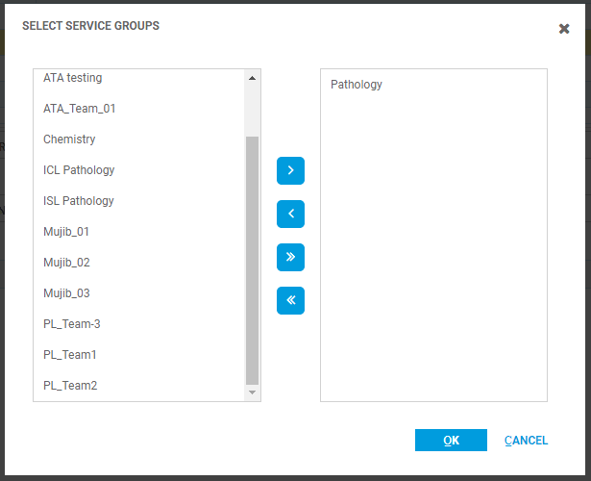

* Add members for that service group by clicking on Edit Member List button in Members Tab.

* In the Infrastructure tab add the Buildings and Rooms.

* In the Details tab add Icolims Site Code for the site.

* Select the default storage location.
  + This configuration can be done after configuring the Storage Location in Storage Location manager.

# Location Configuration

## Location Type Configuration:

* Open Location Types application from “Data Repository > Location Types”.
* Click on Add & Enter the name.

* In the Location Type Layout panel click on add and add layouts.

1. Sublocation Type : Rack

Size : 3

Order : 1

Is Storable? : unchecked

1. Sublocation Type : Shelf

Size : 5

Order : 2

Is Storable? : checked

## Storage Location Configuration:

* Open Storage Location Manager application from “Materials Manager > Storage Location Manager”.
* Select the Site.

* Select Room1 node and click on add.
* Enter Code : BENCHTOP

Name : Benchtop

Type : Room Temperature

* Click Next.

* Select Storage Condition:

* Click Next and finally Finish.

# Equipment Types Configuration

* Open Equipment Types application from “Data Repositories > Equipment Types”.
* Click on Add and add 3 different types:

1. Equipment Types : Bench

Description : Bench

1. Equipment Types : Casette Printer

Description : Casette Printer

1. Equipment Types : Slide Printer

Description : Slide Printer

* Mark Modular for equipment for which there is more than one discrete unit.
* To display a printable list, click Print Report.

# Workflow Configuration

## Add Material Type

* Open Material Types application from “Data Repository > Material Types”.
* Click on Add button and enter Material Type, Description.

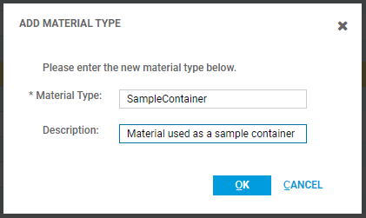

* Click OK.

## Add Material

* Open Material Manager application from “Materials Management > Material Manager”.
* Click on Add button.
* Enter material code, name and select Material Type which has created in Material Types application.

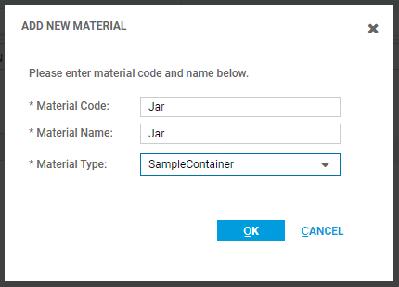

* Now make the material Active by clicking on Status column. Select Active from the dropdown list.
* You can add the Expiration Period and unit from respective columns which used in making the sample as Discard. When sample process with completing its workflow steps, it gets discard after mentioned Expiry period.

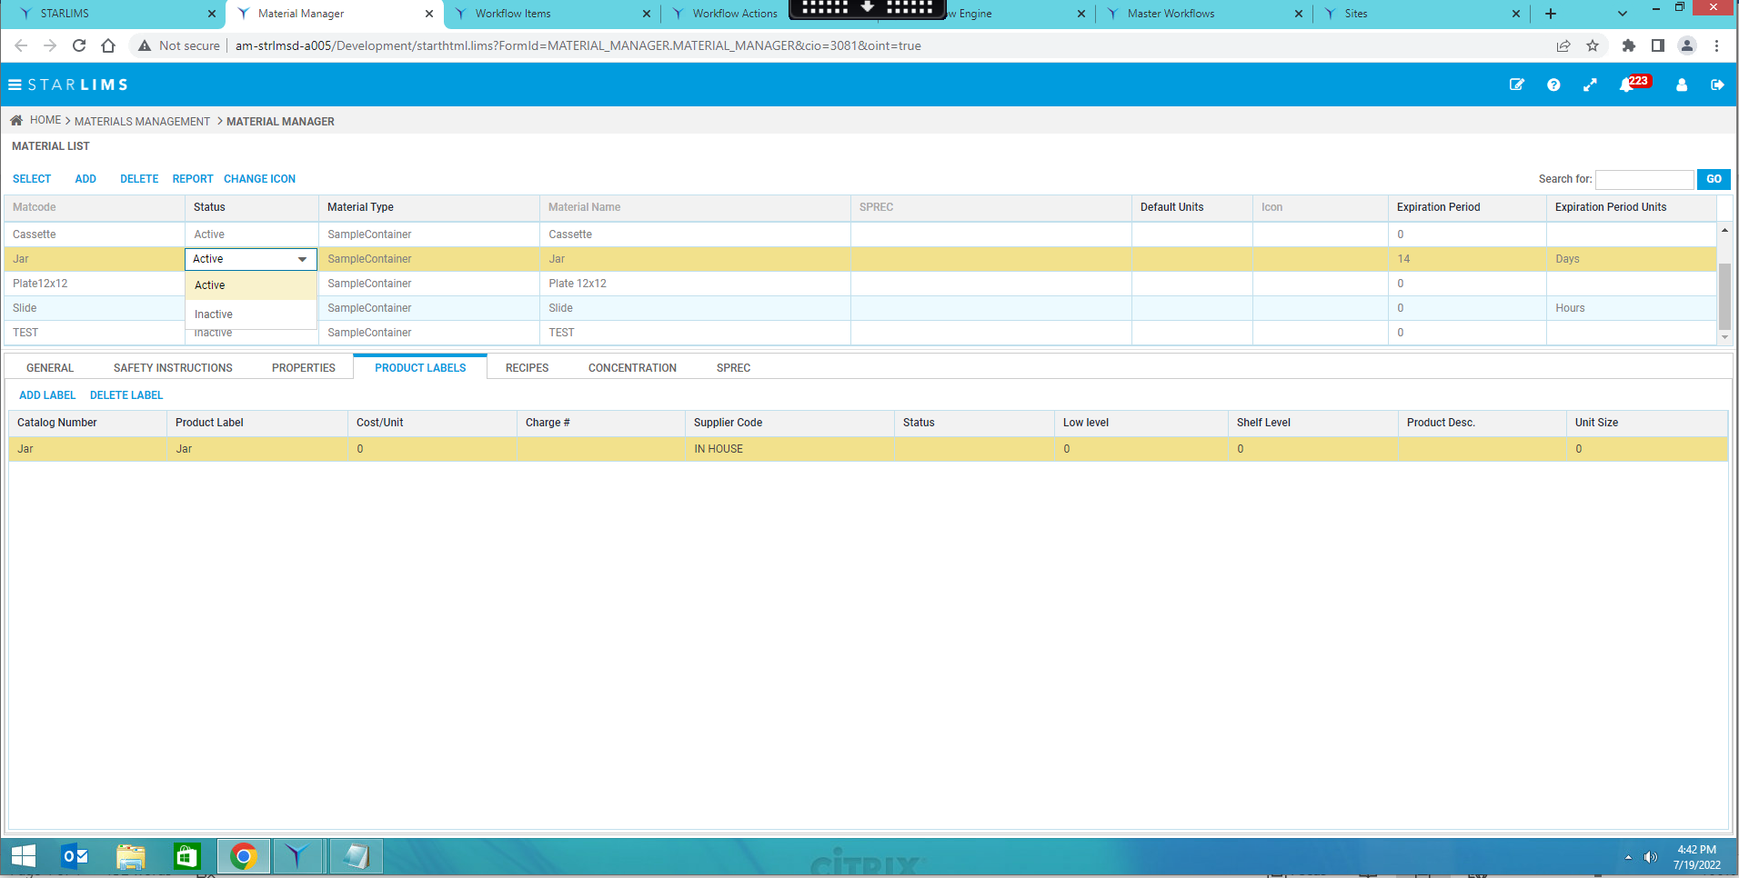

## Add Workflow Items

* Open Workflow Items application from “Workflow Setup > Workflow Items”.
* Add items for input and output of step.
* Write the name of Step in Item Description text box and Click on Add button.
* Item 1 - Tissue in formalin jar
* Item 2 - Grossed tissue in a cassette
* Item 3 - Processed tissue in a cassette
* Item 4 - FFPE Block

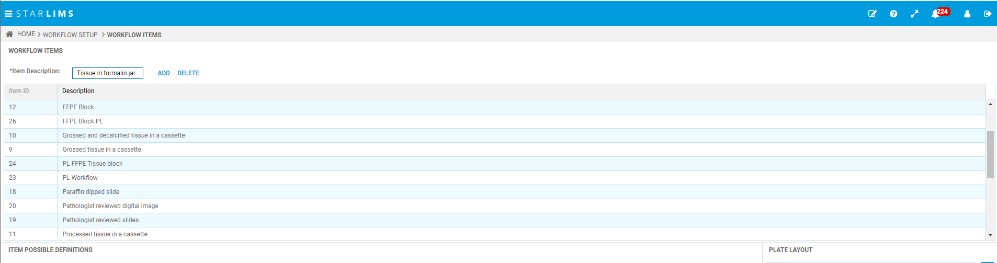

## Add Workflow

* Open Workflow Engine Application from “Workflow Setup > Workflow Engine” .
* Click on Add and enter Workflow Code, Name & Type.
* Workflow Code - GPE

Workflow Name - GrossProcessEmbed

Workflow Type - Default

Description - Pathology - GrossProcessEmbed

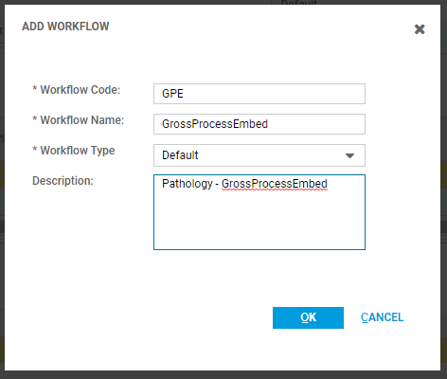

* Now in the Version panel add version.
* In Step panel add 3 steps by clicking on Add button.
* Enter Step Code, Name, Site and Service Group. Check the Sample Result Check box.
* **Step 1** – Step Code : Grossing

Step Name : Grossing

Site : Dublin

Service Group : Pathology

Sample Result : Checked

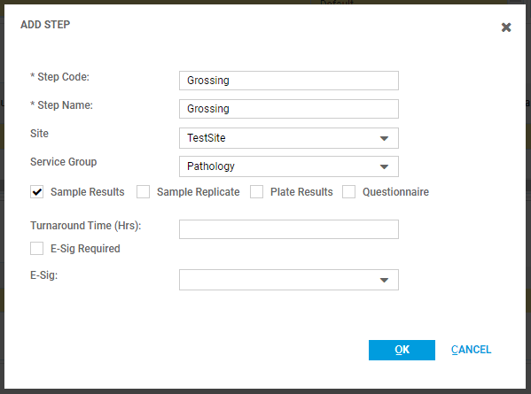

* In Input step setting click on Add and select Workflow Item as **Tissue in jar.**
* In Output step setting click on Add and select Workflow Item as **Grossed tissue in a cassette.**
* Check the checkboxes : **Track Inventory**

**Has Result?**

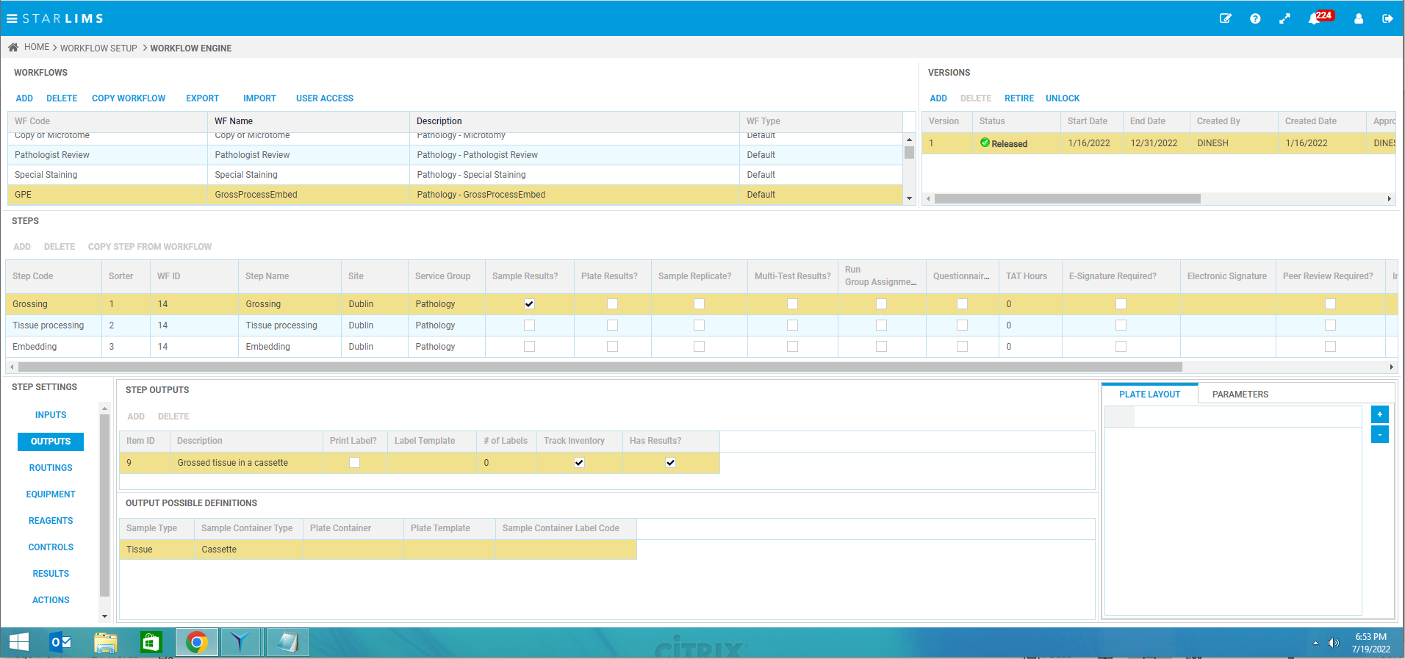

* In Routing step setting click on Add & select:

Output : **Grossed tissue in a cassette**

Routing Type : **Other Routes**

Next Workflow : **GrossProcessEmbed v.1**

Next Workflow Step : **Tissue processing**

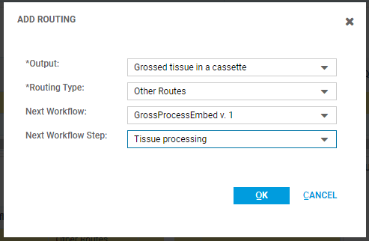

* In Equipment step setting add following Equipment:

Equipment Type : **Bench**

Equipment Type : **Casette Printer**

Equipment Type : **Slide Printer**

* Check the **Testing Equipment** checkbox for all 3 Equipment.

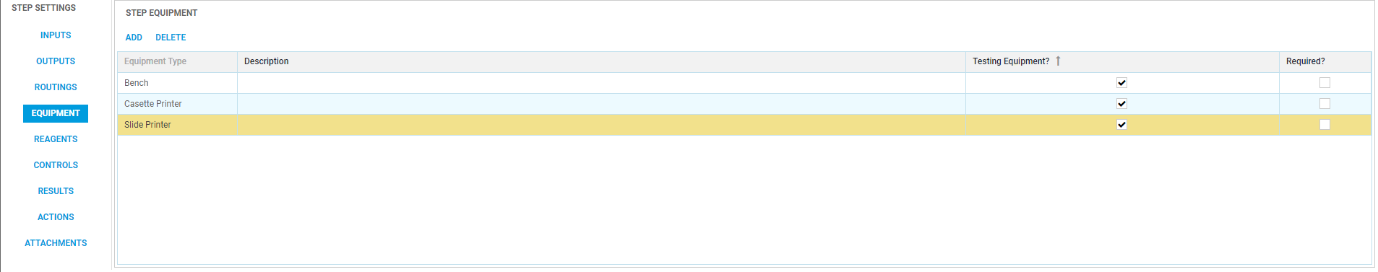

* In Result site setting select RES01 field, click on Caption and add :

Caption : Sample Type

Width : User can configure desired width for each Result field. For Ex. 110

Display Property : Read/Write

Control Type : Combo Box

Look up : Sample Type

* Likewise add settings till RES09:
* The Caption can be configured directly through the grid (in-line editing)

User can add the Lookup for the result field. (for Drop down values)

* Now in Action step settings we can add Transaction for the workflows.
* Select Transaction Type from the list which you want to associate with the Workflow. If the required Transaction Type is not present in the list then click on Add button and add the Type in the list.
* Checked the **Available for Processing?** Checkbox and from the Role Access panel select the role & make **Available?** Checkbox as checked.

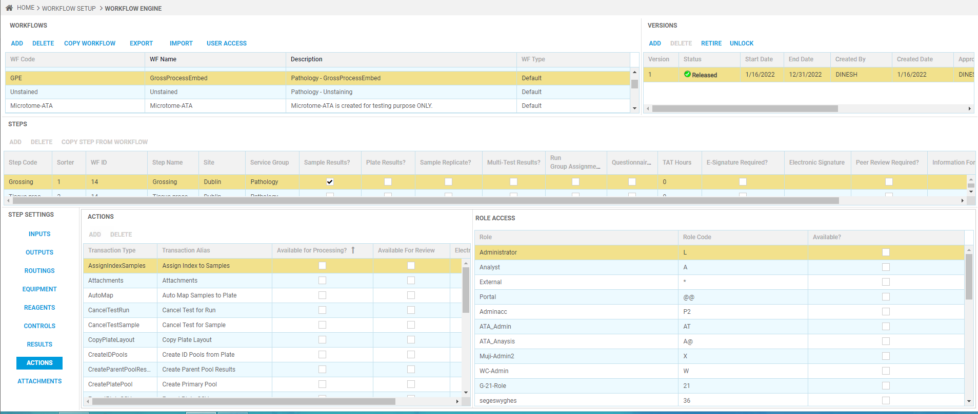

* You can add custom script to each step which will gets execute after the step execution.
* To add custom script, click on Custom Script column and select required script.

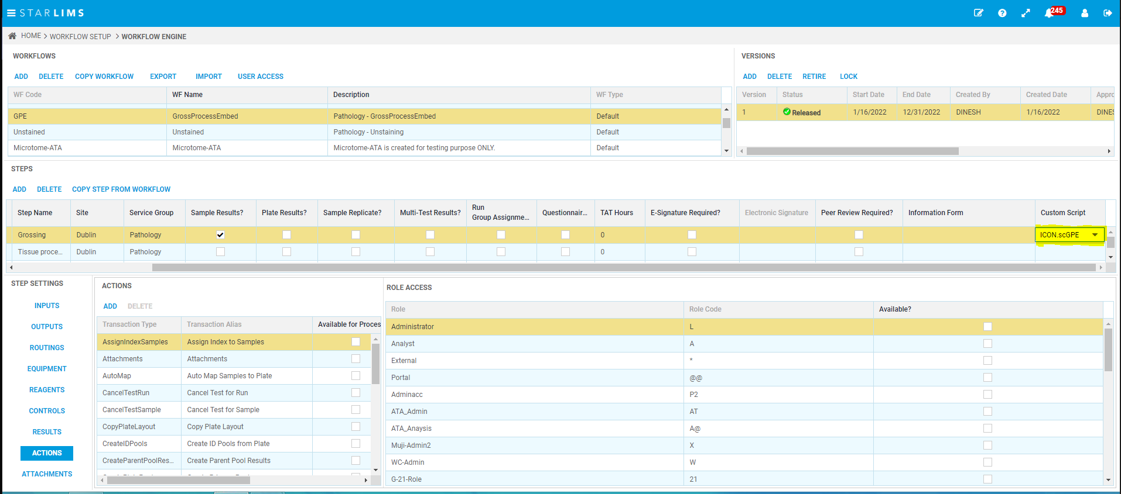

* **Step 2** – Step Code : Tissue processing

Step Name : Tissue processing

Site : Dublin

Service Group : Pathology

Sample Result : Unchecked

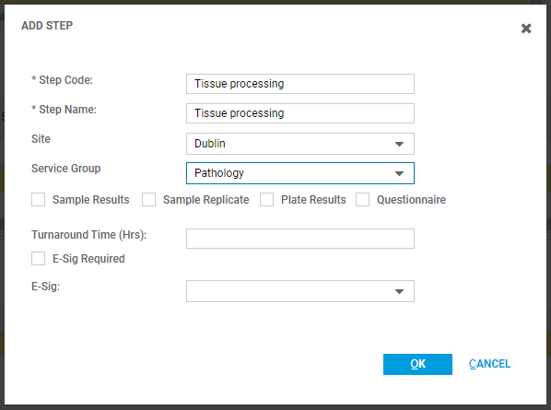

* Similarly like Step 1 add input and output for step 2:

Input : **Grossed tissue in a cassette**

Output : **Processed tissue in a cassette**

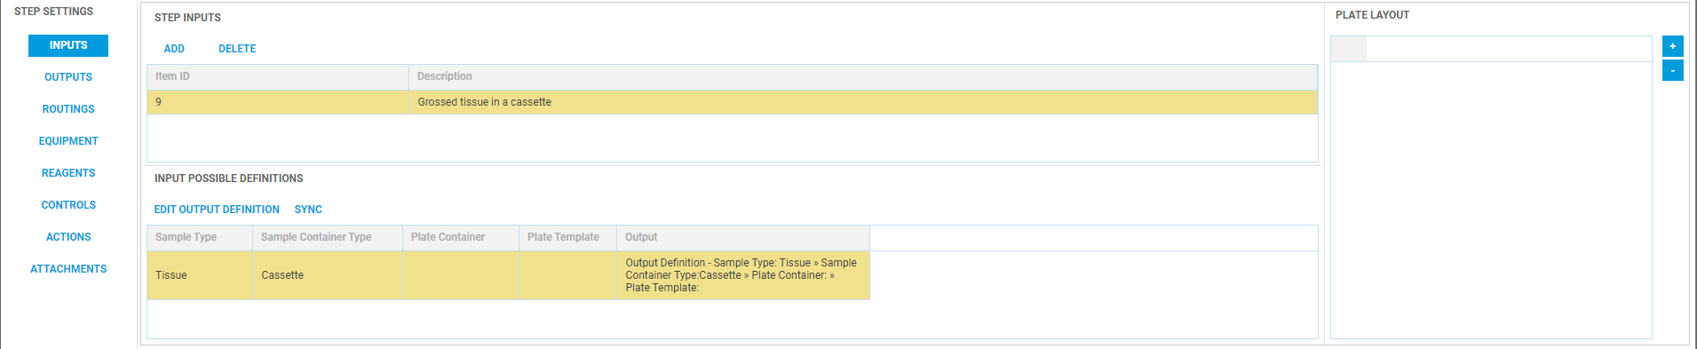

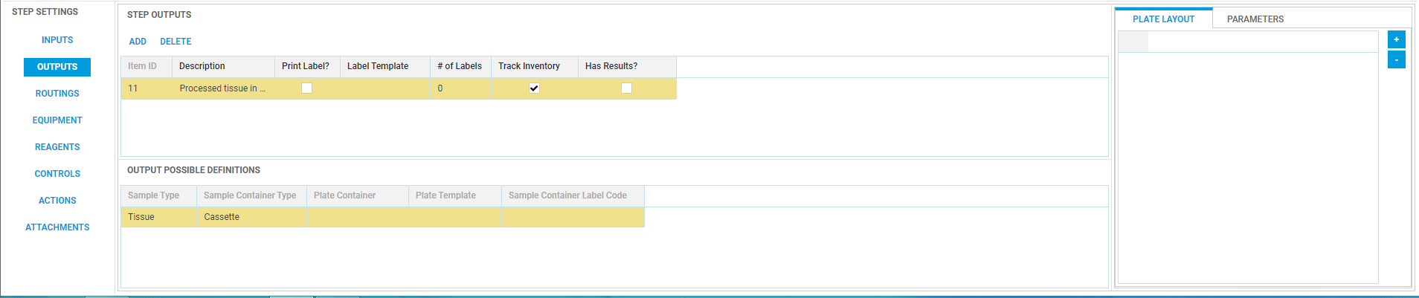

* In Routing step setting click on Add & select:

Output : **Processed tissue in a cassette**

Routing Type : **Other Routes**

Next Workflow : **GrossProcessEmbed v.1**

Next Workflow Step : **Embedding**

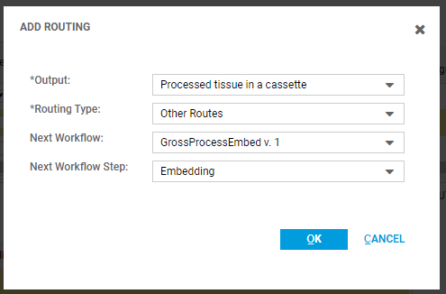

* In Equipment site setting add **TissueProcessor** Equipment type and checked the **Testing Equipment?** Checkbox

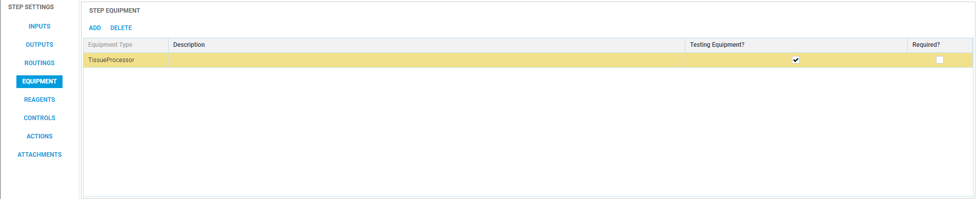

* As we haven’t assign Sample Result to this step no need to add Results.
* You can add custom script to this step as well.
* **Step 3** – Step Code : Embedding

Step Name : Embedding

Site : Dublin

Service Group : Pathology

Sample Result : Unchecked

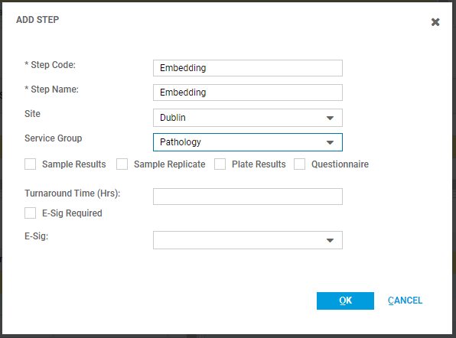

* Similarly like Step 1 add input and output for step 2:

Input : **Processed tissue in a cassette**

Output : **FFPE Block**

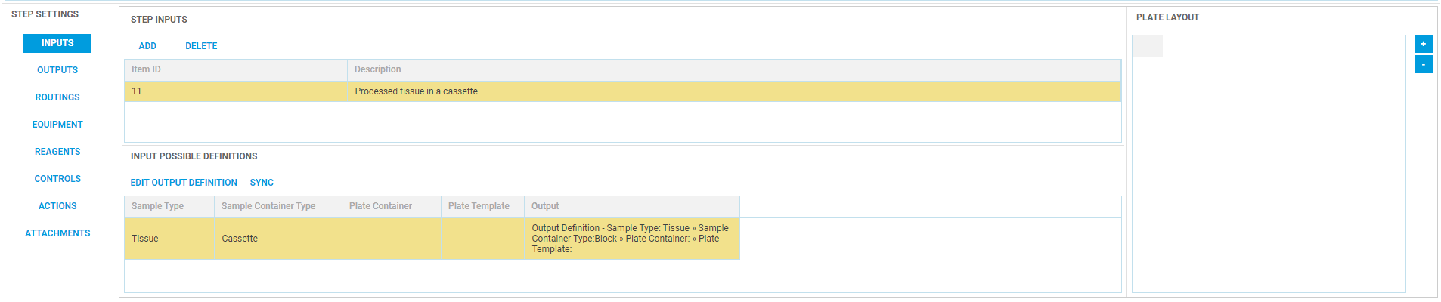

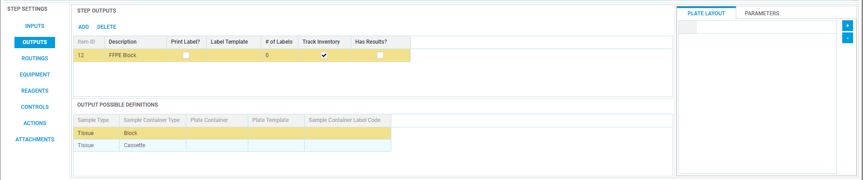

* In Equipment step setting add following Equipment:

Equipment Type : **CryoModule**

Equipment Type : **EmbedModule**

* Check the **Testing Equipment** checkbox for all 2 Equipment

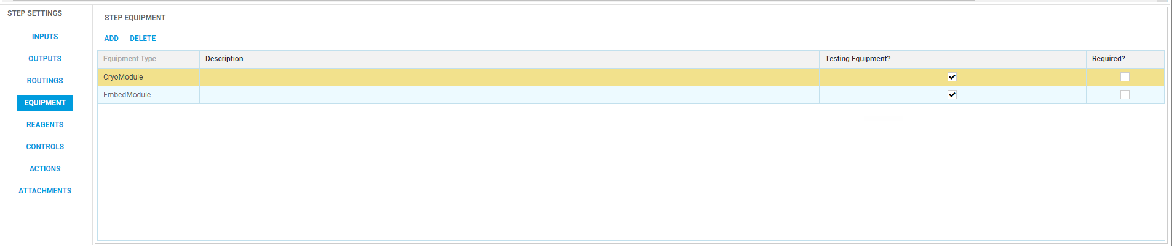

* As we haven’t assign Sample Result to this step no need to add Results.
* **Release the Version.**

# Master Workflow Configuration

* Open Master Workflows application from “Workflow Setup > Master Workflows”.
* Click on Add and enter details.
* Code : Block Preparation

Name : Block Preparation

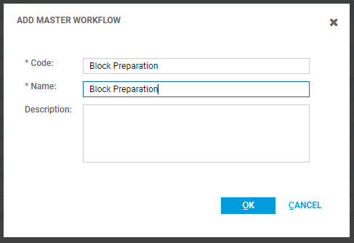

* In the bottom panel add the workflow which we have created in Workflow Engine application.

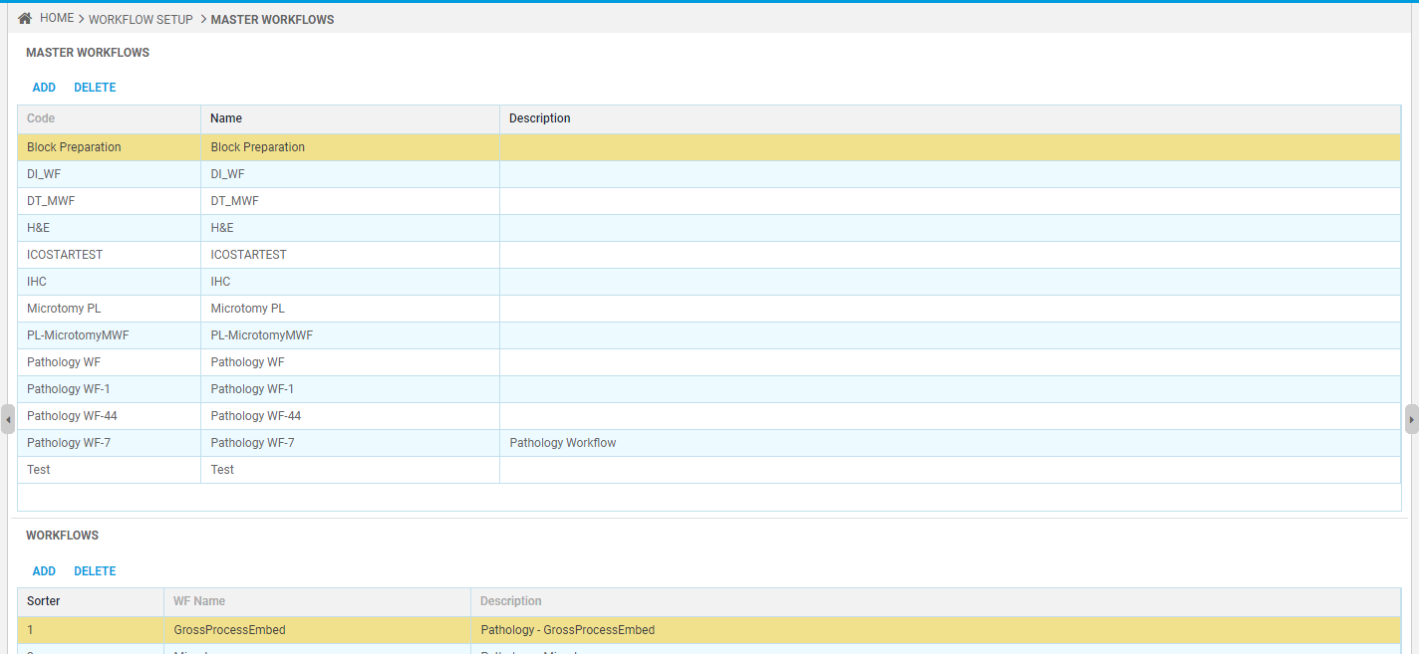

# Test Configuration

* Open Test Manager application from “Test/Method Management > Test Manager”.
* Click on Add to add to add new test and enter:

Test Name : **FTBLKPRP –** Fresh Tissue Block Preparation

Test Library : Pathology

Method : Default

Service Group : Pathology

Equipment Type : N/A

Container : Jar, Tissue

Checked : Auto Load Analyte and Close the Wizard

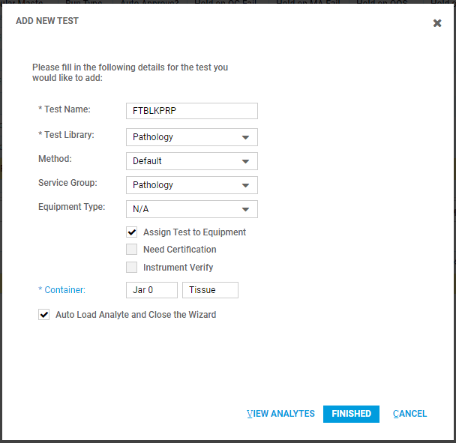

* Click Finished.
* Select the test and add master workflow in “Molecular Master Workflow Id” Column.
* Select Block Preparation Master workflow.

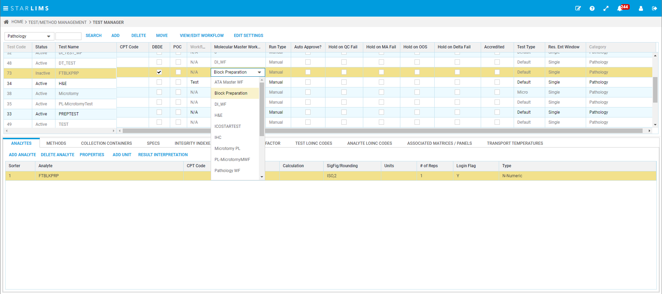

* Now in Analyte Tab Add below 4 Analyte:

FTBLKBIO

FTDATE

FTBLK

FTTIME

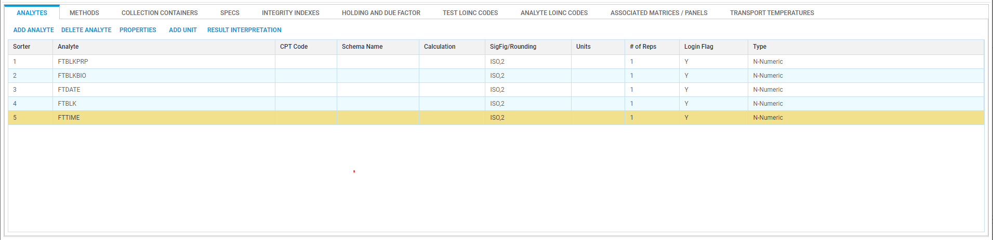

* In Method tab click on Release button to release the method.
* In SPECS tab Select Human Test plan and click on Add to Plan button.

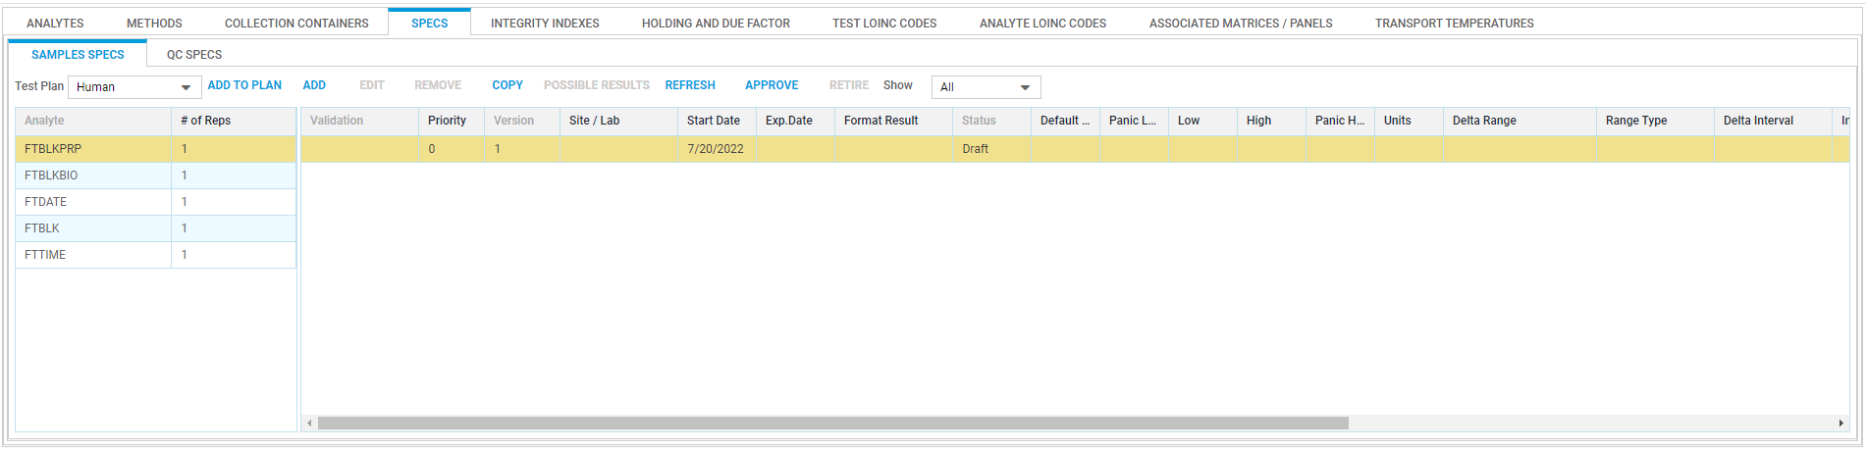

* In Associate Matrices / Panels tab click on Edit List and add **Human** plan.

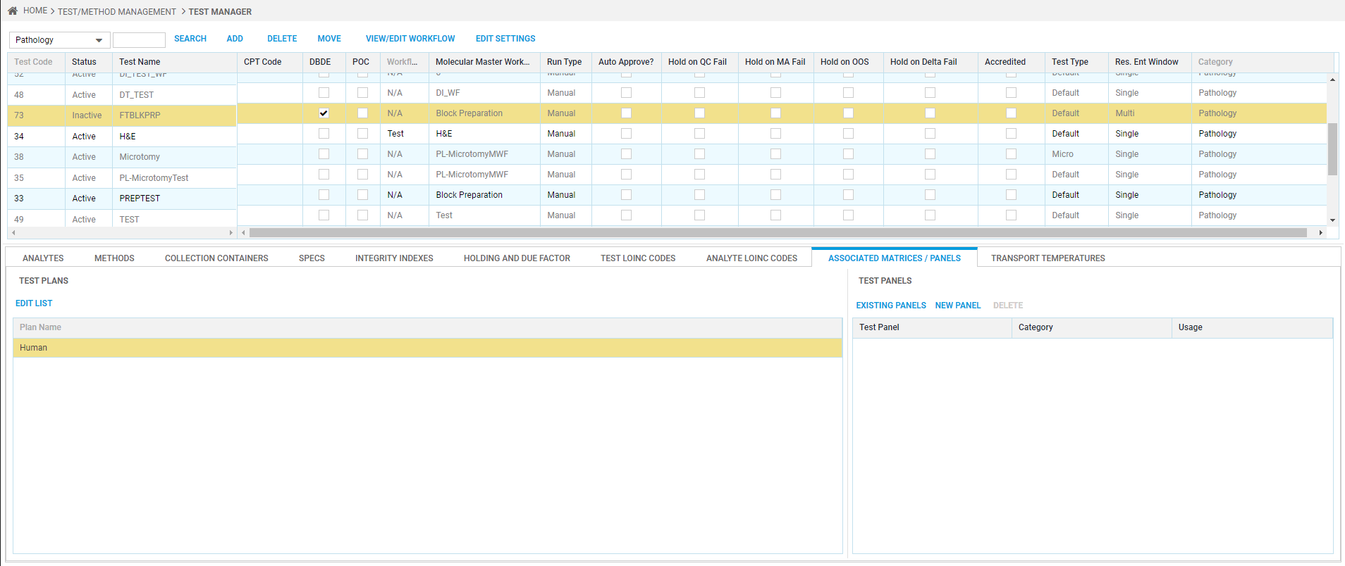

* Now in above grid change the status of the test as Active. Click on Ok if it ask to create new Test Plan.

# Comments Management Configuration

* Go to Comments Management application from Main Menu. Utilities > Comments Management
* Graphical user interface, application, email

  Description automatically generated
* Click on Add button to add Comments Category.
* Graphical user interface, application

  Description automatically generated
* Add the usage for Comments category.
* Graphical user interface, text

  Description automatically generated
* Now Add the comment based upon the category and usage.
* Graphical user interface, application

  Description automatically generated
* Graphical user interface, text, application

  Description automatically generated
* Select the Expiry date as future date.
* Comment is added as Draft status.
* Table

  Description automatically generated with medium confidence
* Now, Approve the comment.
* Graphical user interface, text, application, email

  Description automatically generated
* Provide the Username, Password and Reason.
* Now the comment is in Released mode.
* Graphical user interface, application

  Description automatically generated
* Only released comments will be available for selection.
* The separate Comments category are required for Cancellation and Workflow Results comments as per below.
* Graphical user interface, application, email

  Description automatically generated
* Graphical user interface, application

  Description automatically generated
* The Usage is changed based on the requirement.
* These Comments code will be useful while entering the comments in Workflow Processing and Cancelling the test.

# Manual Steps to Accession Sample and process the workflow

***NOTE: The below Trial Manager Configuration is ONLY required to do the unit testing.***

***In Real scenarios, the Trial will be configured through Trial Manager API.***

## Add New Trial

* Open Trial Manager application from “Clinical Trial > Trial Manager”.
* Click on Add to create new Trial.

Trail Code : Block_Prep_Trial

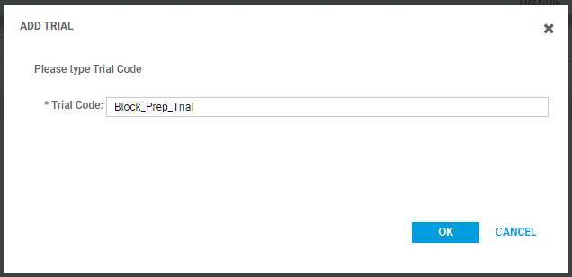

* Add particular Region in Regions & Facilities Tab.

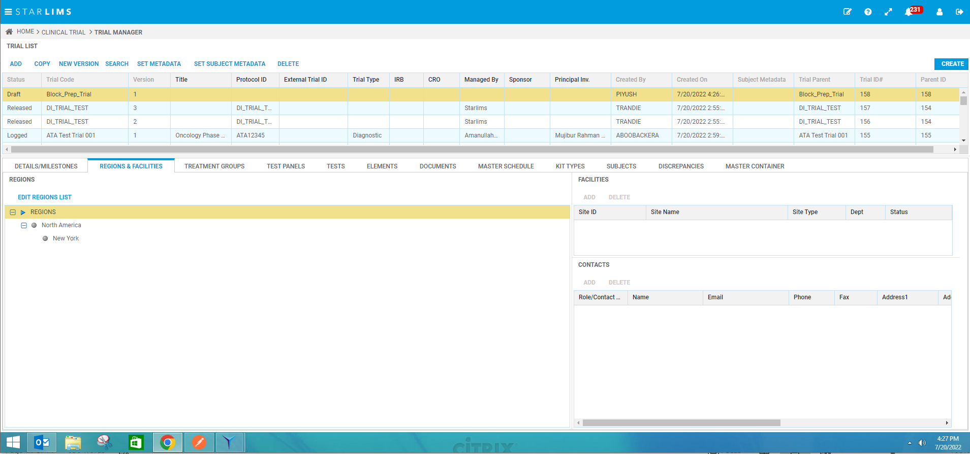

* In Treatment Groups Tab add new treatment group and make its status as Active.

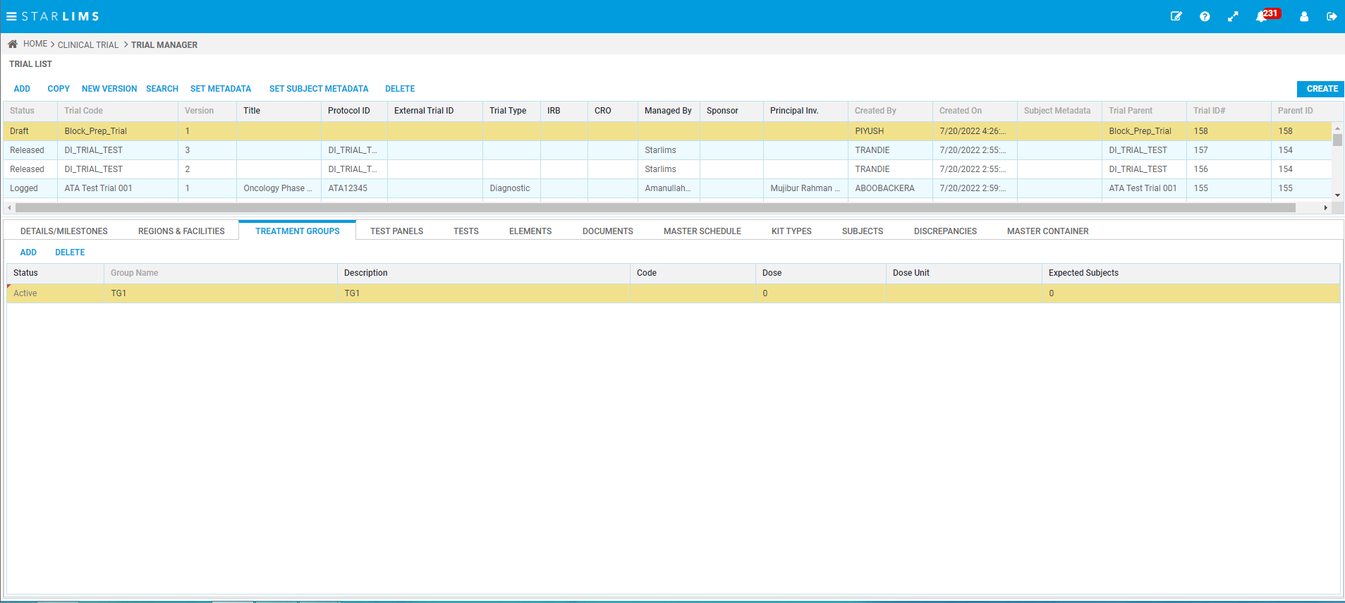

* In Test Panel Tab click on add and select the test from list.

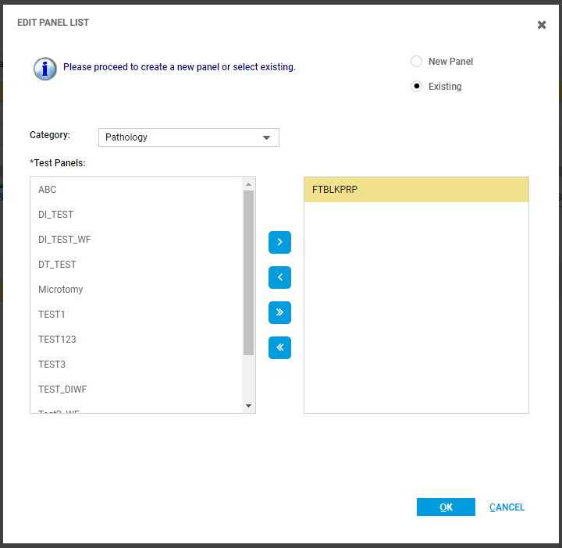

* In Elements Tab add new element and visit.

Element : Schedule

Visit : Visit 1

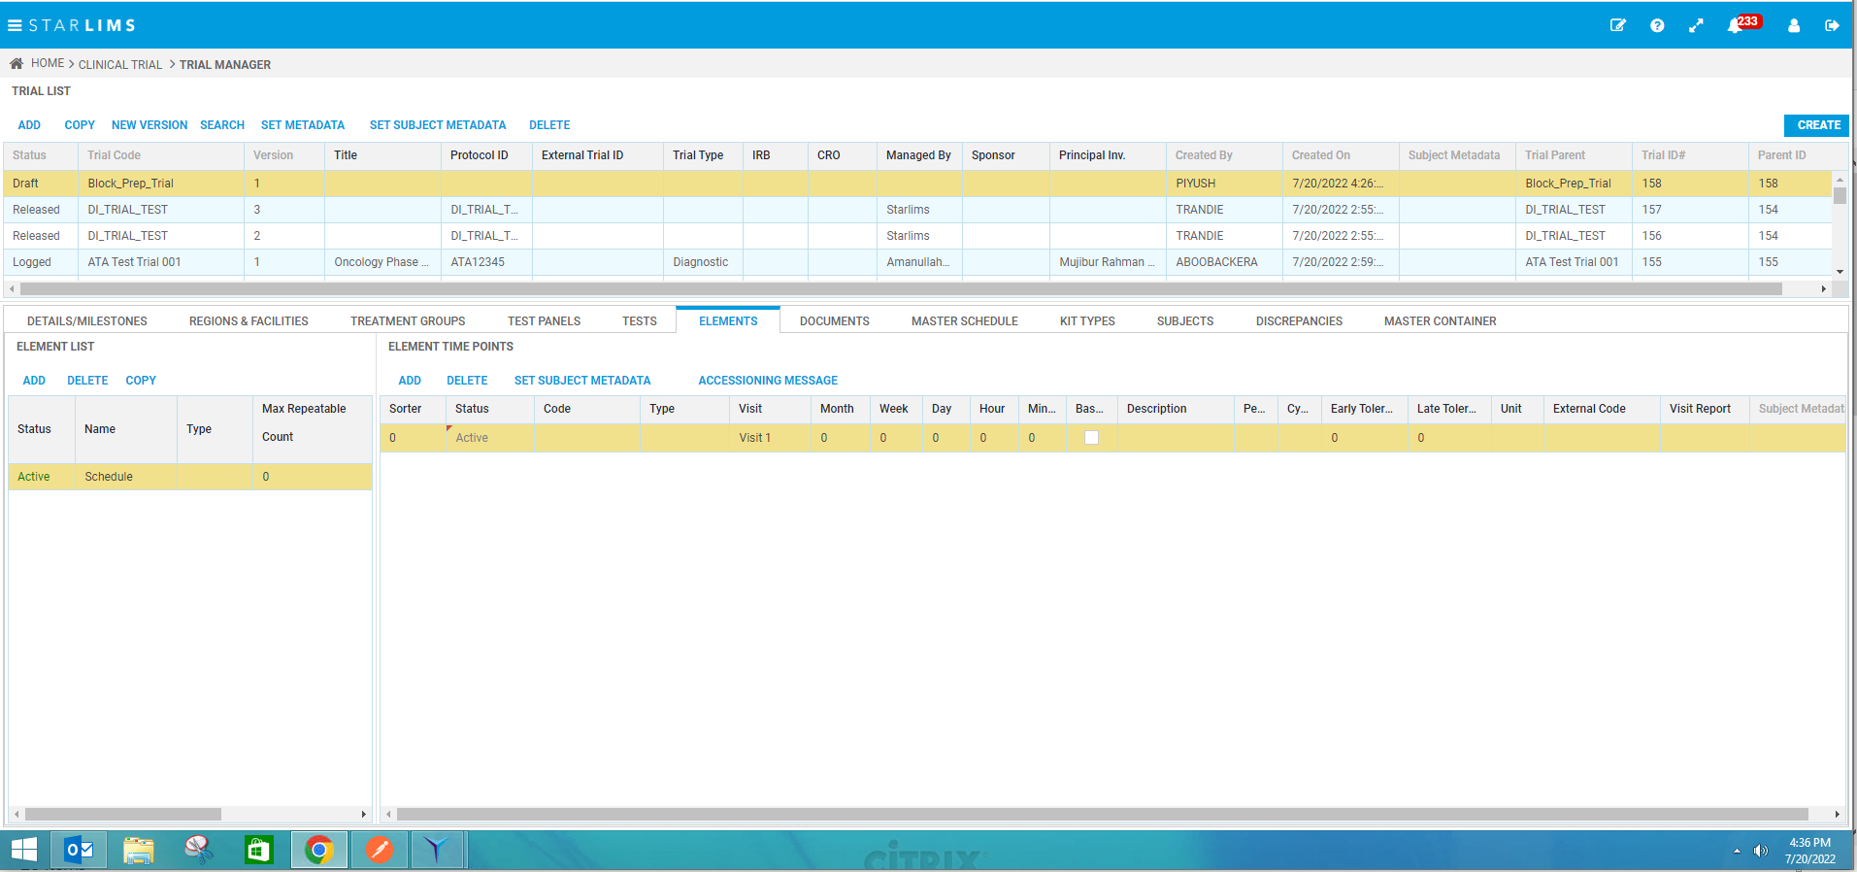

* Make Visit status as Active.
* In Master Schedule Tab click on Add.

Select Visit 1

Select TG1 Treatment Group

Select Panel

Click Add & then Finish button

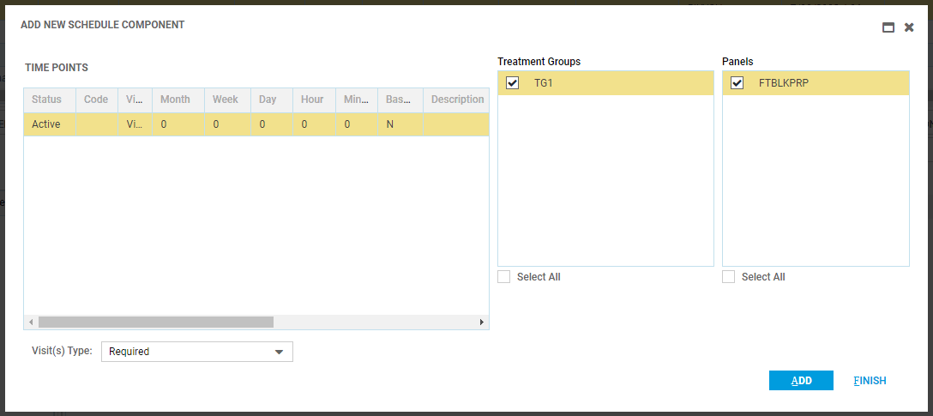

* In **Master Container Tab** click on add & enter:

Container Type : Jar

Sample Type : Tissue

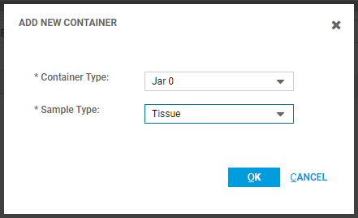

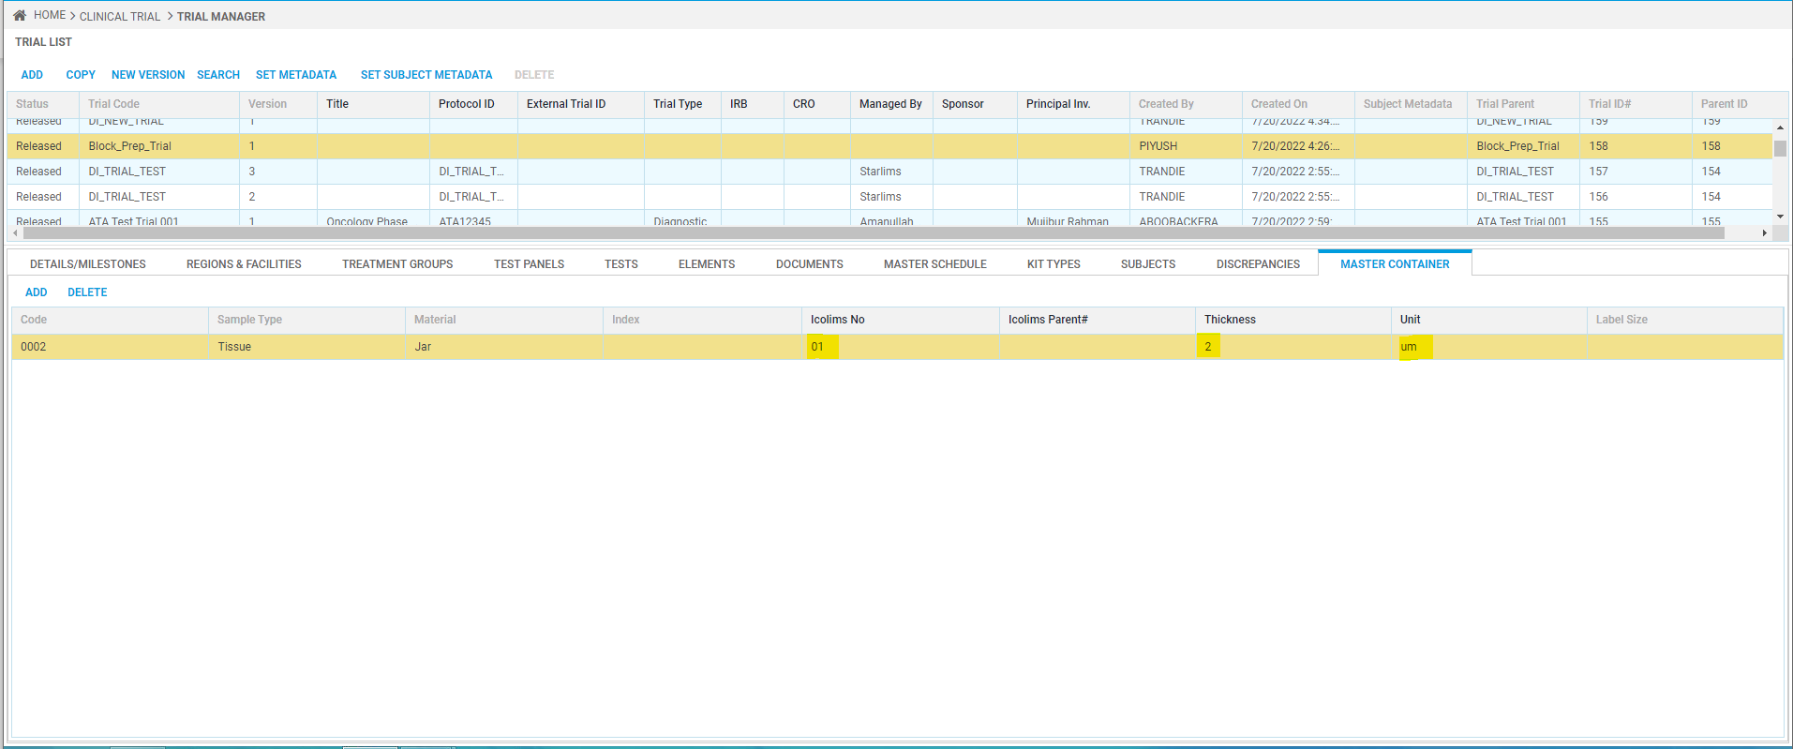

* Likewise, you can add multiple containers.
* Click on CREATE button on the Top right corner
* Click on REVIEW button.
* Click on RELEASE button.

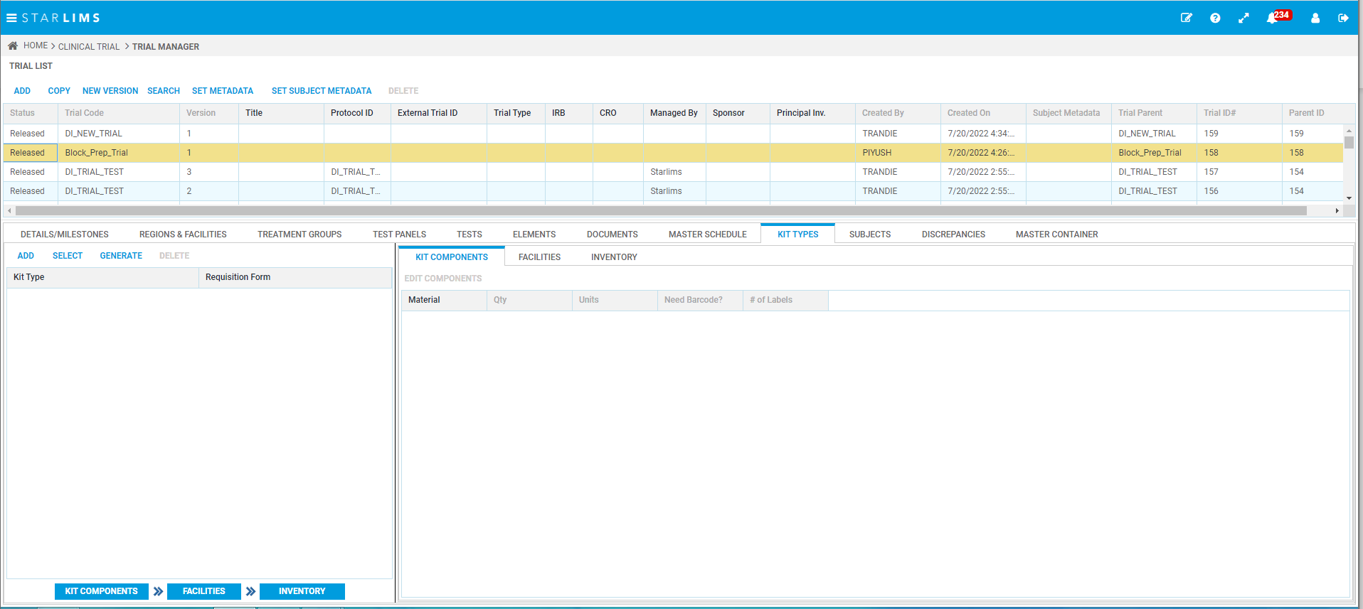

***NOTE: The below manual accession is only required for the unit testing purpose.***

***In real scenario, the samples will be accessioned through HL7 Message.***

## Create Accession

* Open Trial Sample Login application from ”Clinical Accessioning > Trial Sample Login”.
* Click on New which will create new Accession. Select required details:

Trail Code : Block_Prep_Trial (Vers. 1)

Visit : Visit 1

Subject : Sub01

Treatment Group : TG1

Collection Site : Internal Organization-Internal

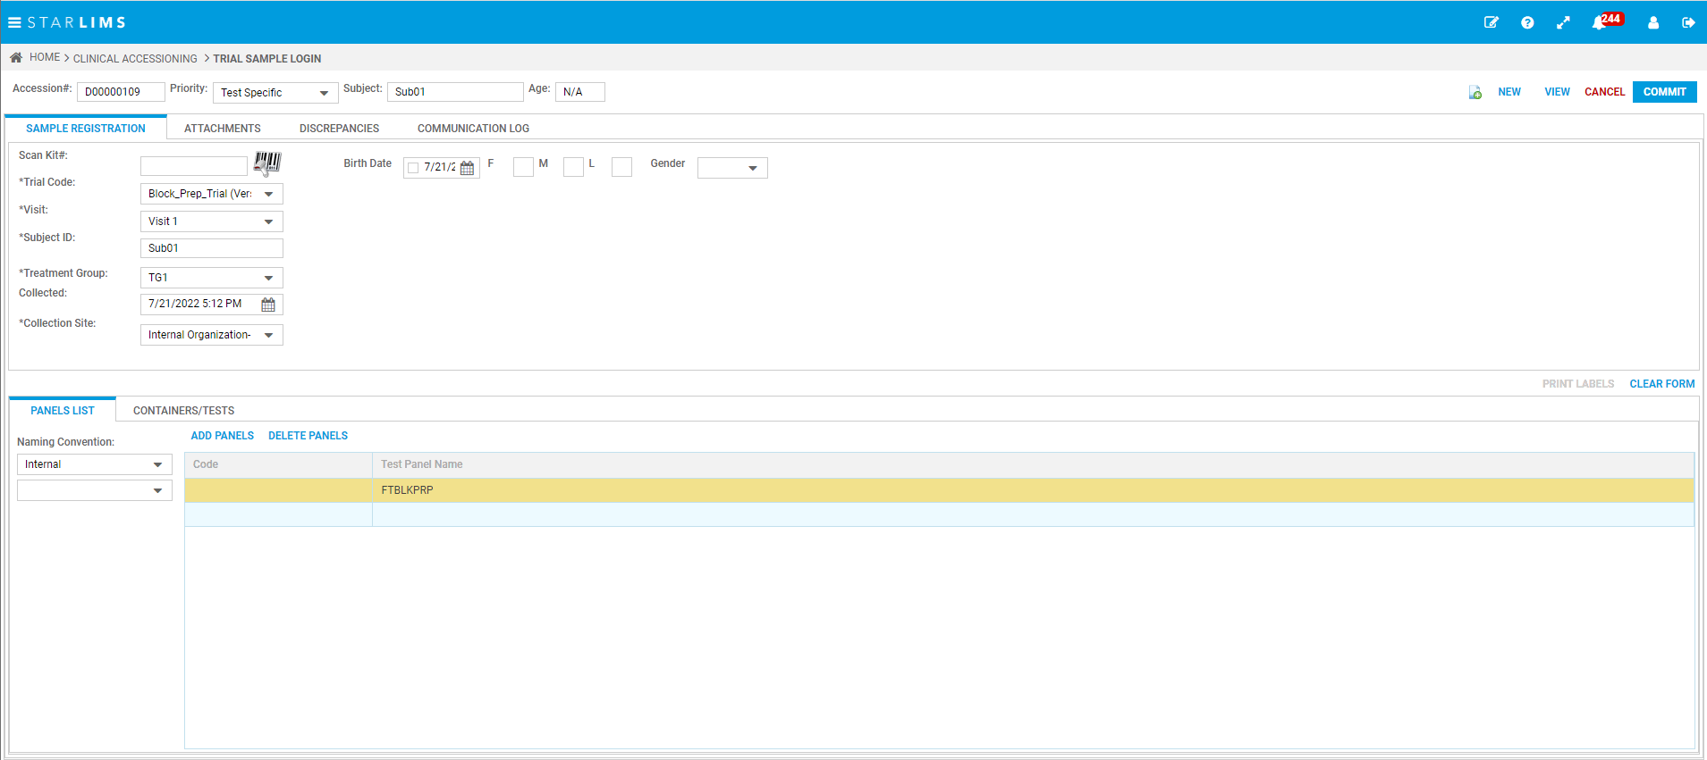

* Click on Commit button.

## Process Workflow

* Open My Team Workflow Processing from “Reminders > My Team Workflow Processing”.
* In the Workflow / Step Panel You will see **GrossProcessEmbed** Workflow.
* Expand that node and select **Grossing** step.

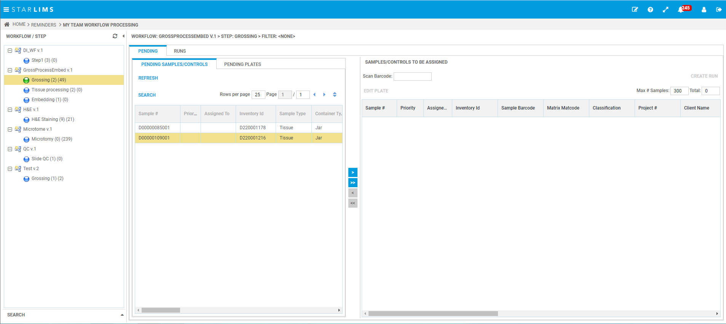

* Select the Sample from Pending tab, add it in right panel using ‘>’ button and click on Create Run.
* Now the sample will get visible in the Runs Tab.

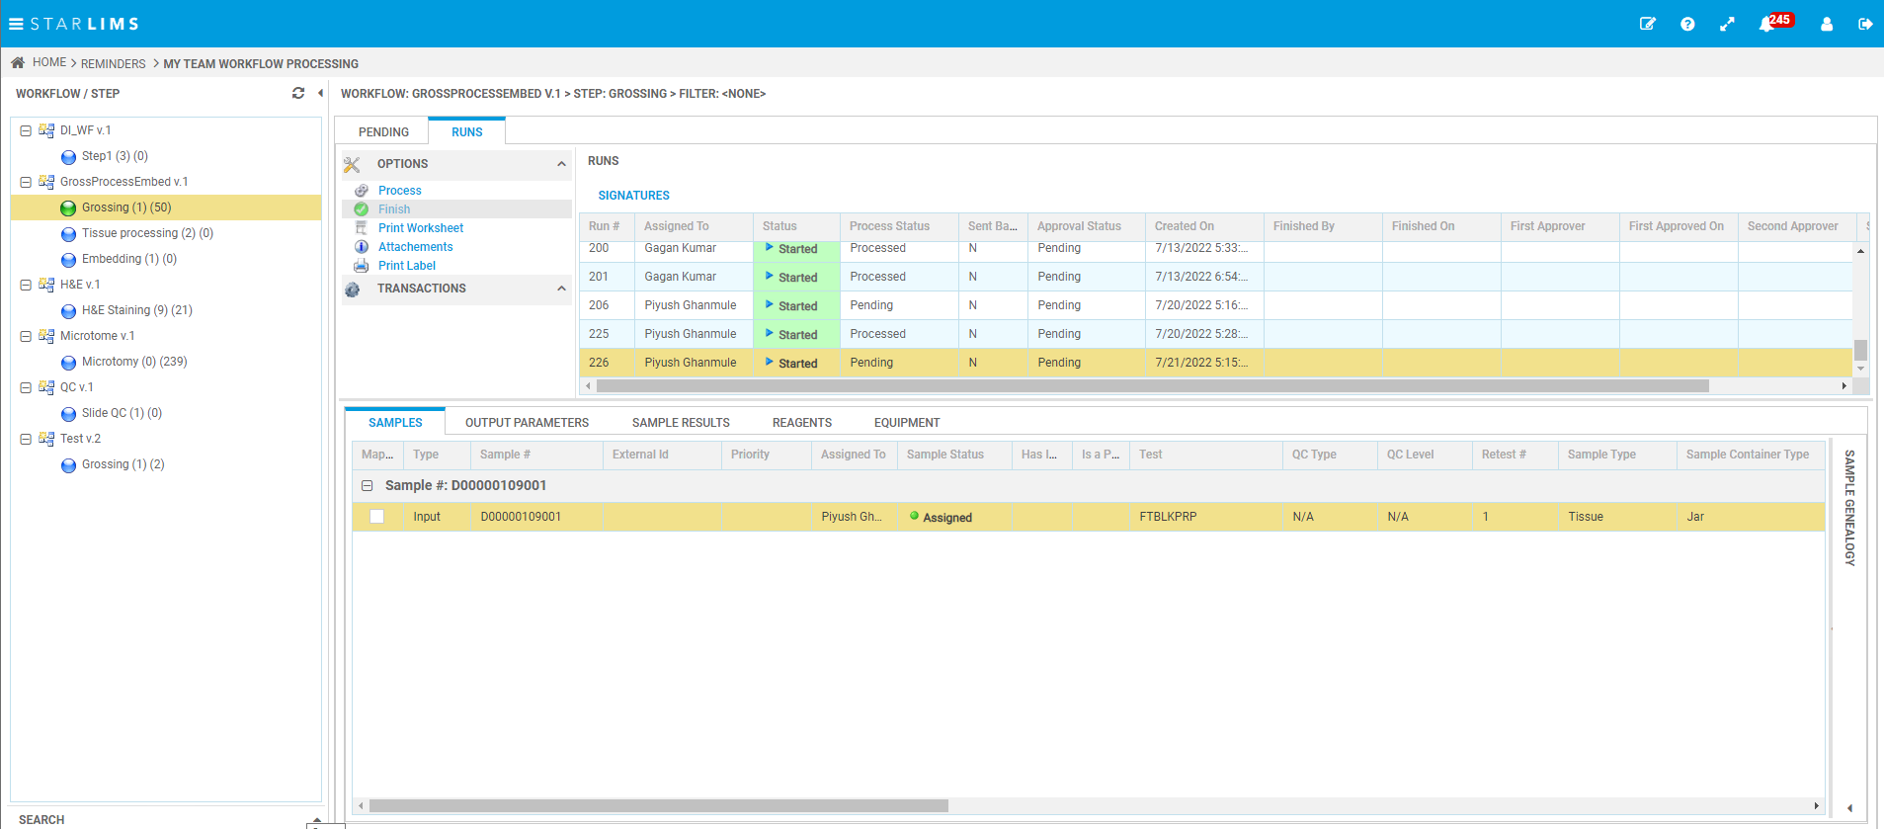

* Click on Process button to complete the Workflow step for the sample.
* Note : When we click on Process it will calculate the discard date for that sample using the Expiration period mentioned in Material Manager application and the current date.
* After processing the sample, you will see the output type of sample in Sample Tab.